Q11:

[SELECT](http://localhost/phpmyadmin/url.php?url=https://dev.mysql.com/doc/refman/8.0/en/select.html) Customer_Name FROM customer WHERE Customer_Name [LIKE](http://localhost/phpmyadmin/url.php?url=https://dev.mysql.com/doc/refman/8.0/en/string-comparison-functions.html%23operator_like) '_o%';

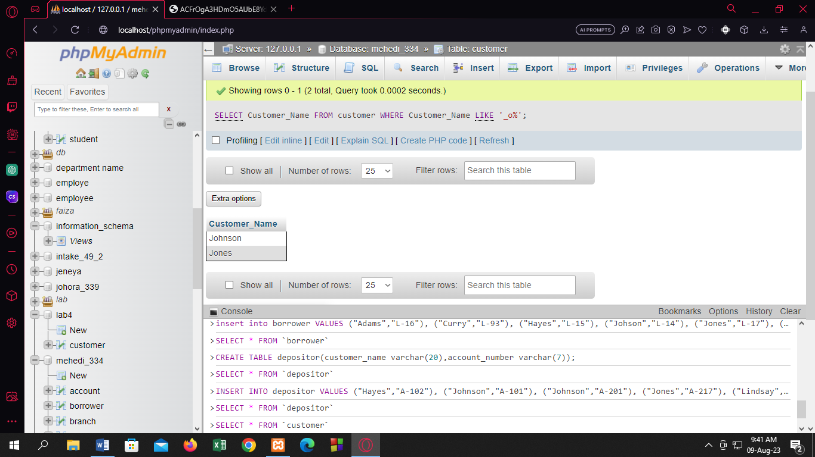

Q12:

[SELECT](http://localhost/phpmyadmin/url.php?url=https://dev.mysql.com/doc/refman/8.0/en/select.html) Customer_Name FROM customer WHERE Customer_Name [LIKE](http://localhost/phpmyadmin/url.php?url=https://dev.mysql.com/doc/refman/8.0/en/string-comparison-functions.html%23operator_like) '%o%';

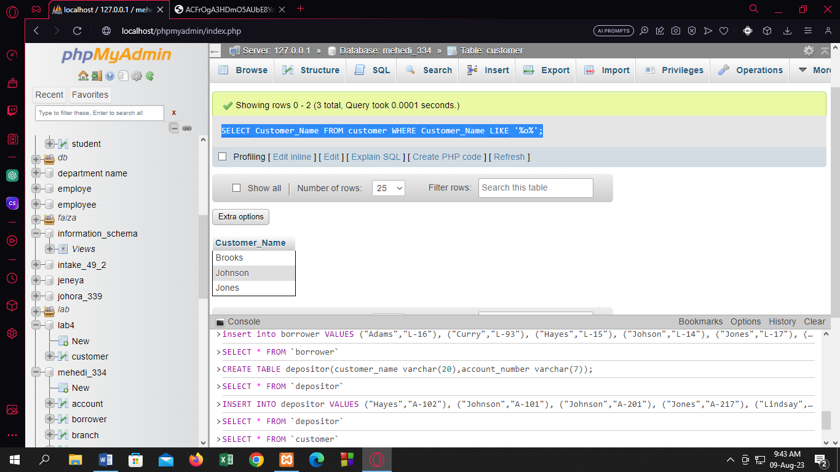

Q13:

[SELECT](http://localhost/phpmyadmin/url.php?url=https://dev.mysql.com/doc/refman/8.0/en/select.html) Customer_Name,Length(Customer_Name)"LEngth" FROM customer;

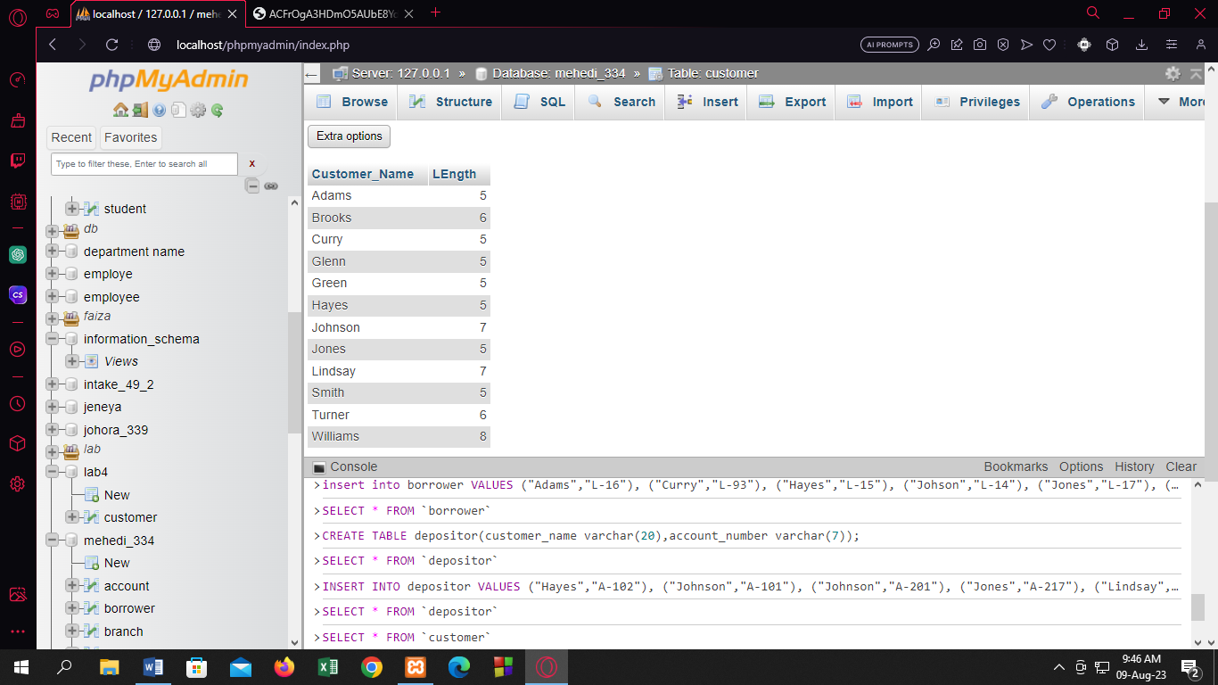

Q14:

[SELECT](http://localhost/phpmyadmin/url.php?url=https://dev.mysql.com/doc/refman/8.0/en/select.html) Customer_Name,SUBSTR(Customer_Name,1,3) FROM customer;

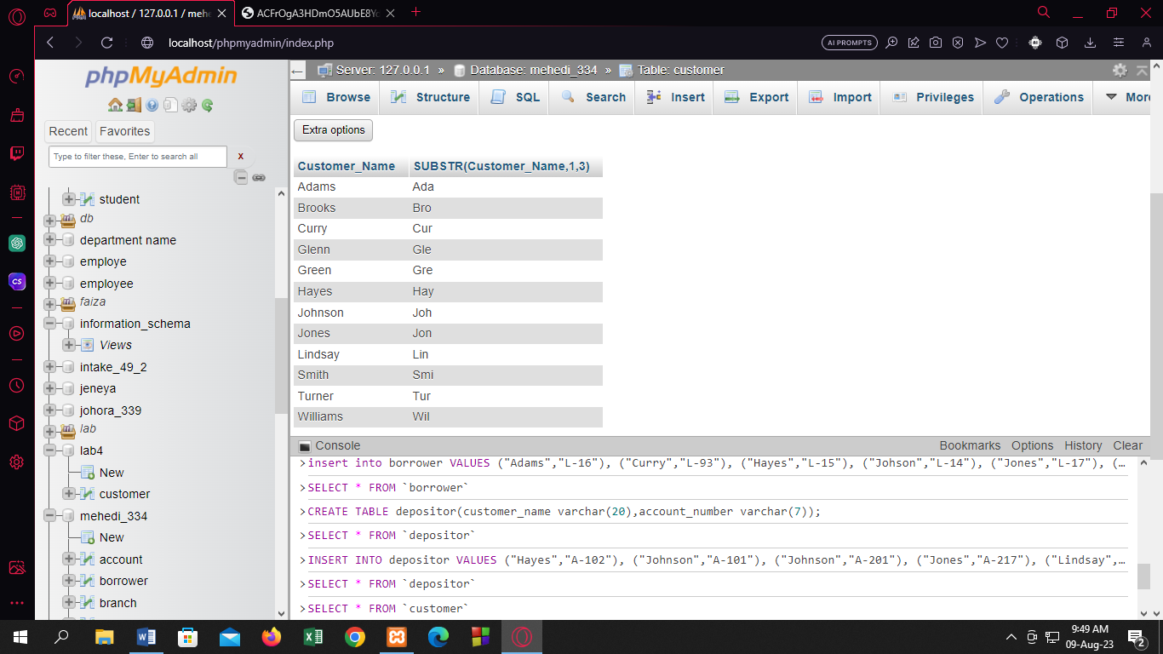

NEW:

Q1:

[SELECT](http://localhost/phpmyadmin/url.php?url=https://dev.mysql.com/doc/refman/8.0/en/select.html) Customer_City,[COUNT](http://localhost/phpmyadmin/url.php?url=https://dev.mysql.com/doc/refman/8.0/en/aggregate-functions.html%23function_count)(Customer_Name)"Total No of Customers" FROM customer GROUP BY Customer_City;

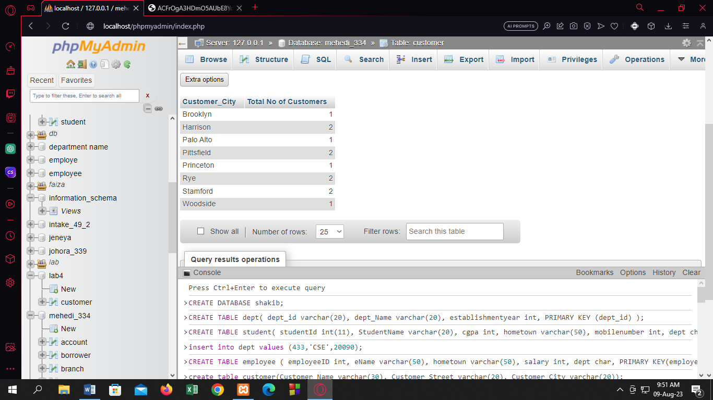

Q2:

[SELECT](http://localhost/phpmyadmin/url.php?url=https://dev.mysql.com/doc/refman/8.0/en/select.html) Branch_name,[COUNT](http://localhost/phpmyadmin/url.php?url=https://dev.mysql.com/doc/refman/8.0/en/aggregate-functions.html%23function_count)(Loan_number)"No of Loans" FROM loan GROUP BY Branch_name;

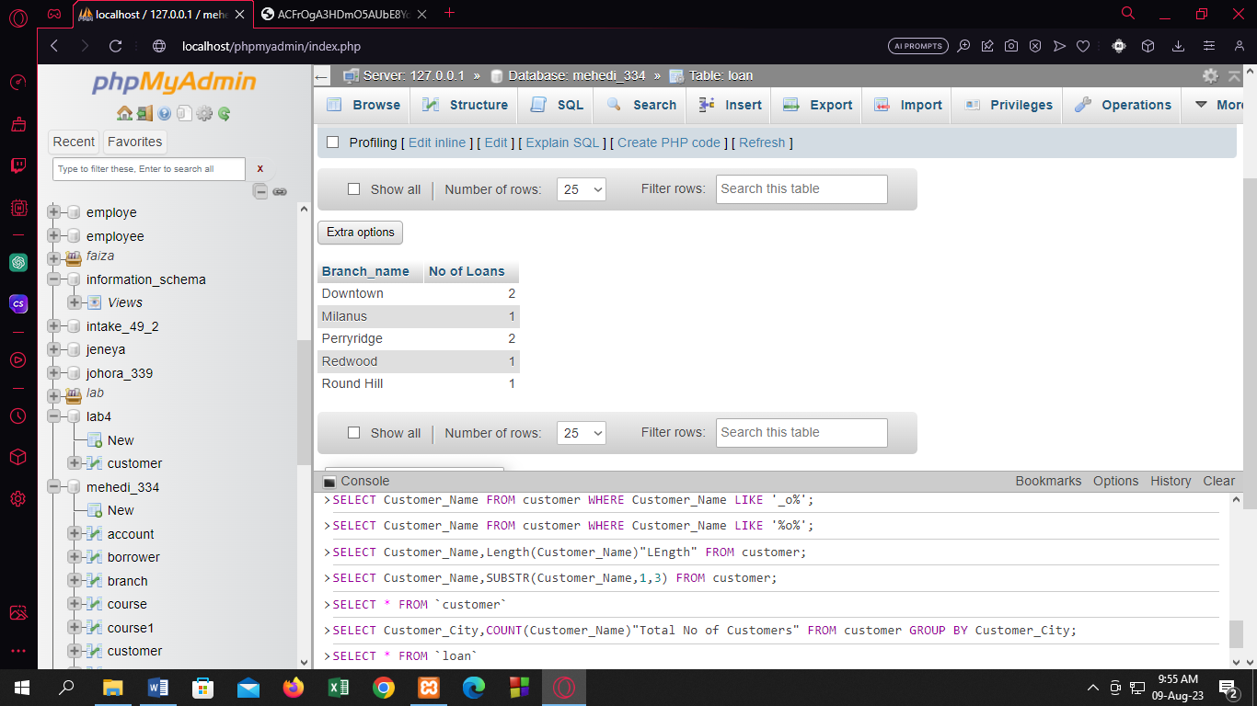

Q3:

[SELECT](http://localhost/phpmyadmin/url.php?url=https://dev.mysql.com/doc/refman/8.0/en/select.html) Branch_name,[SUM](http://localhost/phpmyadmin/url.php?url=https://dev.mysql.com/doc/refman/8.0/en/aggregate-functions.html%23function_sum)(Amount) FROM loan GROUP BY Branch_name HAVING [SUM](http://localhost/phpmyadmin/url.php?url=https://dev.mysql.com/doc/refman/8.0/en/aggregate-functions.html%23function_sum)(Amount)>1200;

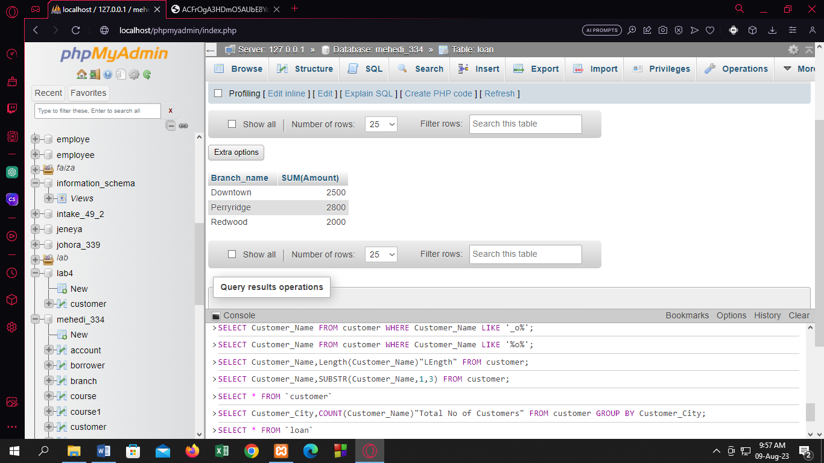

Q4:

[SELECT](http://localhost/phpmyadmin/url.php?url=https://dev.mysql.com/doc/refman/8.0/en/select.html) Branch_name,[AVG](http://localhost/phpmyadmin/url.php?url=https://dev.mysql.com/doc/refman/8.0/en/aggregate-functions.html%23function_avg)(Amount) "Average Amount" FROM loan GROUP BY Branch_name;

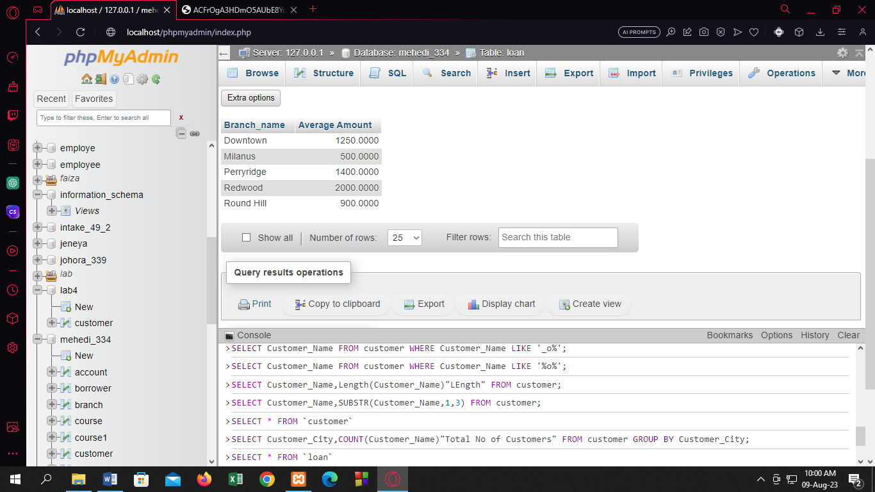

Q5:

[SELECT](http://localhost/phpmyadmin/url.php?url=https://dev.mysql.com/doc/refman/8.0/en/select.html) Branch_name,[SUM](http://localhost/phpmyadmin/url.php?url=https://dev.mysql.com/doc/refman/8.0/en/aggregate-functions.html%23function_sum)(Amount) "Sum Amount" FROM loan GROUP BY Branch_name;

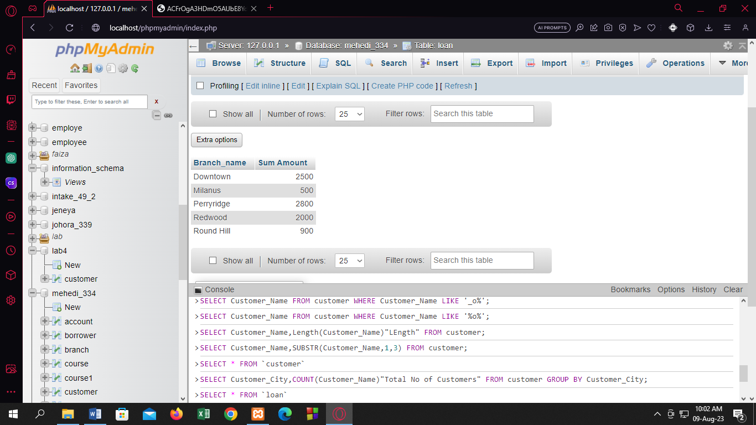

Q6:

[SELECT](http://localhost/phpmyadmin/url.php?url=https://dev.mysql.com/doc/refman/8.0/en/select.html) [COUNT](http://localhost/phpmyadmin/url.php?url=https://dev.mysql.com/doc/refman/8.0/en/aggregate-functions.html%23function_count)(*) FROM loan;

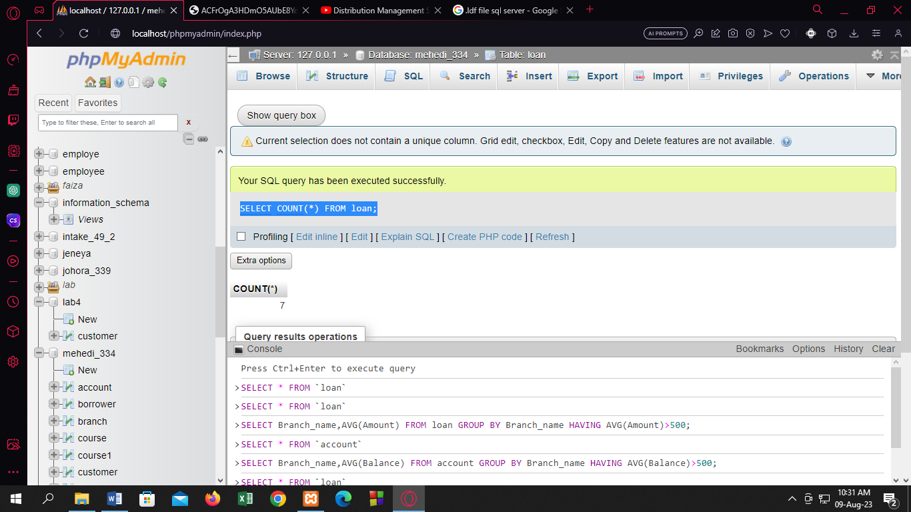

[SELECT](http://localhost/phpmyadmin/url.php?url=https://dev.mysql.com/doc/refman/8.0/en/select.html) [COUNT](http://localhost/phpmyadmin/url.php?url=https://dev.mysql.com/doc/refman/8.0/en/aggregate-functions.html%23function_count)(*) FROM account;



Q7:

[SELECT](http://localhost/phpmyadmin/url.php?url=https://dev.mysql.com/doc/refman/8.0/en/select.html) Branch_name,[AVG](http://localhost/phpmyadmin/url.php?url=https://dev.mysql.com/doc/refman/8.0/en/aggregate-functions.html%23function_avg)(Amount) FROM loan GROUP BY Branch_name HAVING [AVG](http://localhost/phpmyadmin/url.php?url=https://dev.mysql.com/doc/refman/8.0/en/aggregate-functions.html%23function_avg)(Amount)>500;

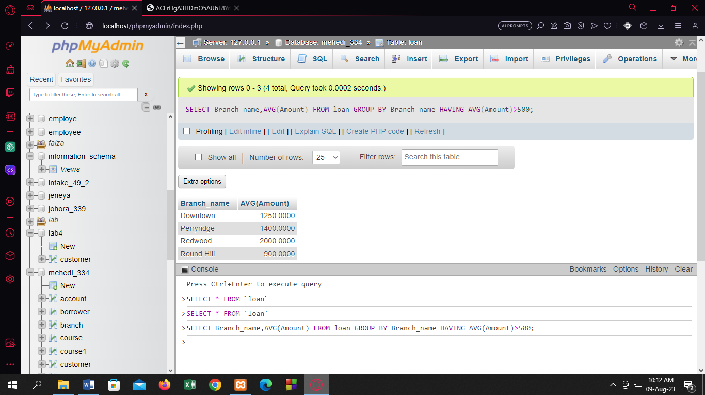

[SELECT](http://localhost/phpmyadmin/url.php?url=https://dev.mysql.com/doc/refman/8.0/en/select.html) Branch_name,[AVG](http://localhost/phpmyadmin/url.php?url=https://dev.mysql.com/doc/refman/8.0/en/aggregate-functions.html%23function_avg)(Balance) FROM account GROUP BY Branch_name HAVING [AVG](http://localhost/phpmyadmin/url.php?url=https://dev.mysql.com/doc/refman/8.0/en/aggregate-functions.html%23function_avg)(Balance)>500;

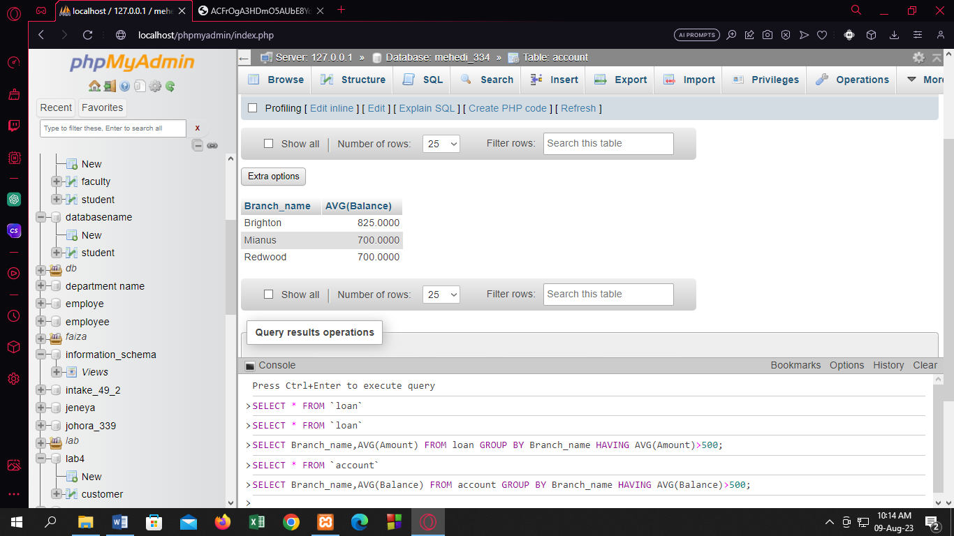

Q8:

[SELECT](http://localhost/phpmyadmin/url.php?url=https://dev.mysql.com/doc/refman/8.0/en/select.html) Customer_name FROM borrower UNION [SELECT](http://localhost/phpmyadmin/url.php?url=https://dev.mysql.com/doc/refman/8.0/en/select.html) Customer_Name FROM depositor;

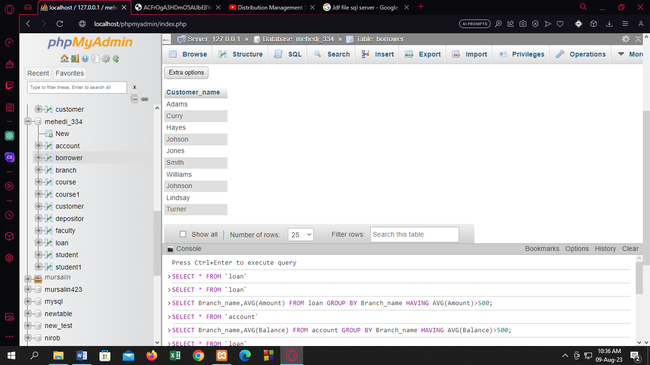

Q9:

[SELECT](http://localhost/phpmyadmin/url.php?url=https://dev.mysql.com/doc/refman/8.0/en/select.html) Customer_name FROM borrower intersect [SELECT](http://localhost/phpmyadmin/url.php?url=https://dev.mysql.com/doc/refman/8.0/en/select.html) Customer_Name FROM depositor;

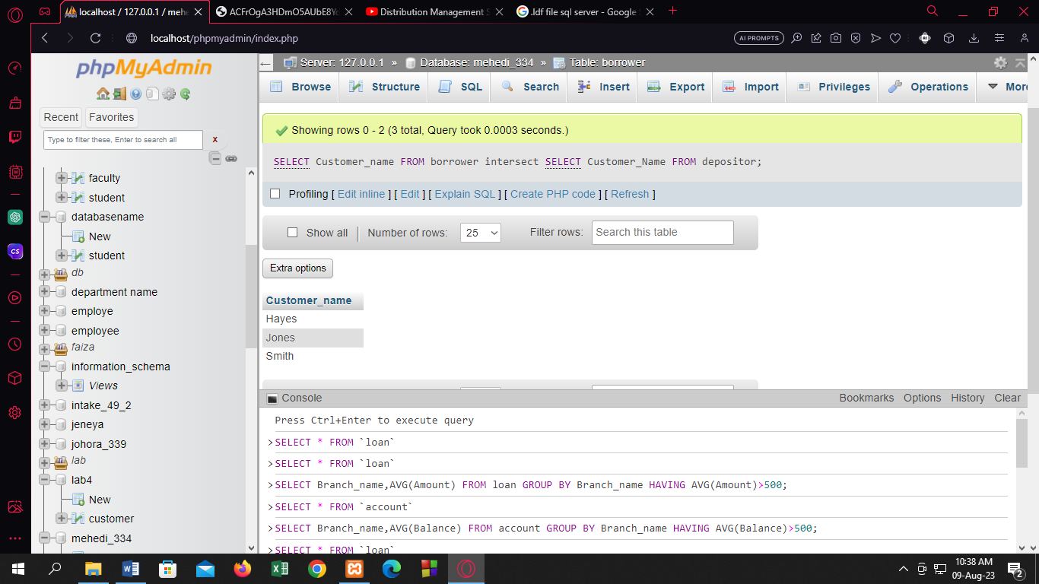

Q10:

[SELECT](http://localhost/phpmyadmin/url.php?url=https://dev.mysql.com/doc/refman/8.0/en/select.html) Customer_name FROM depositor WHERE Customer_Name [NOT](http://localhost/phpmyadmin/url.php?url=https://dev.mysql.com/doc/refman/8.0/en/logical-operators.html%23operator_not) [IN](http://localhost/phpmyadmin/url.php?url=https://dev.mysql.com/doc/refman/8.0/en/comparison-operators.html%23function_in)( [SELECT](http://localhost/phpmyadmin/url.php?url=https://dev.mysql.com/doc/refman/8.0/en/select.html) Customer_Name FROM borrower);

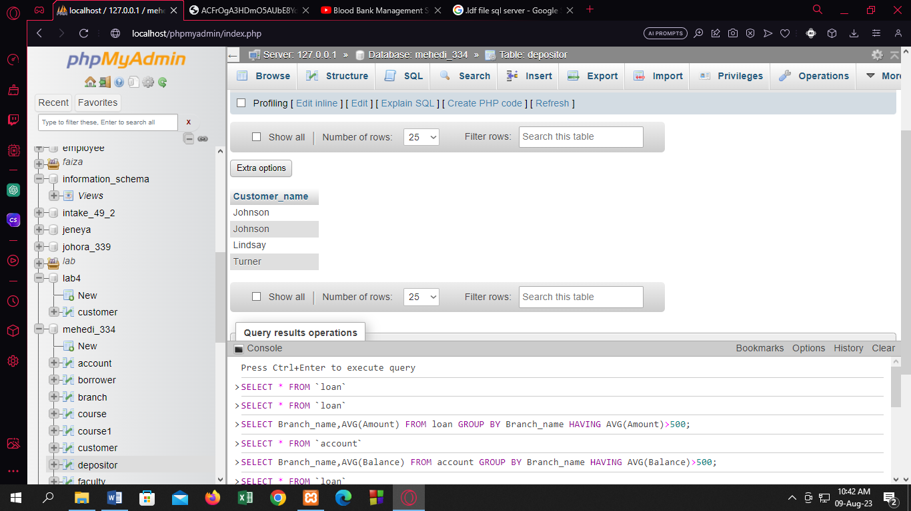

Q11:

[ALTER](http://localhost/phpmyadmin/url.php?url=https://dev.mysql.com/doc/refman/8.0/en/alter-table.html) [TABLE](http://localhost/phpmyadmin/url.php?url=https://dev.mysql.com/doc/refman/8.0/en/alter-table.html) branch CHANGE COLUMN Branch_city city varchar(30);

